Little SPARK: Simple Play Adaptations to Reference for Kids

Wipe Clean Weighted Lap Pad 3lb
Description: | Image:
The Wipe Clean Weighted Lap Pad (Small) is 13" x 8", made of 100% polyurethane, contains 3 lbs of steel pellets in a separate lining.  Use with children weighing 30+ lbs to provide gentle weight on a child’s lap to sooth the child and provide a gentle reminder to remain seated.  Purchasing Information | 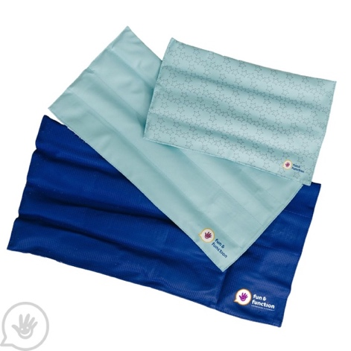

Who Might Benefit?
Those who need support staying seated, sustaining attention, or managing anxiety and behaviors during seated activities.
Why Use?
Enhance body awareness, support self-regulation, and improve focus and engagement during activities.
Instructions for Use: | Adaptation Ideas:
Environmental Considerations  - Use in all settings, on the go, and in group and one-on-one activities.  Positioning/Alternate Positioning  - Use primarily in a seated position on the child’s lap.  Basic Play/Use Extended Play/Use  - Place on lap during seated activities, circle time, incorporate in bed time routines. Play a game asking the child to place the lap pad on different body parts to increase body awareness. | Stabilize It  - Dycem or shelf liner to stabilize the lap pad on any surface.  Add Sensory Cues  - Add texture cues or alternative sensory input on the surface.  Communication Supports  - Visual supports like communication cards and social narratives can help a child request the lap pad, communicate putting lap pad on/off, and identify feelings.  DIY Alternatives  - How to make your own weighted lap pad (Chicago Occupational Therapy)

Words to Encourage Play/Use
On  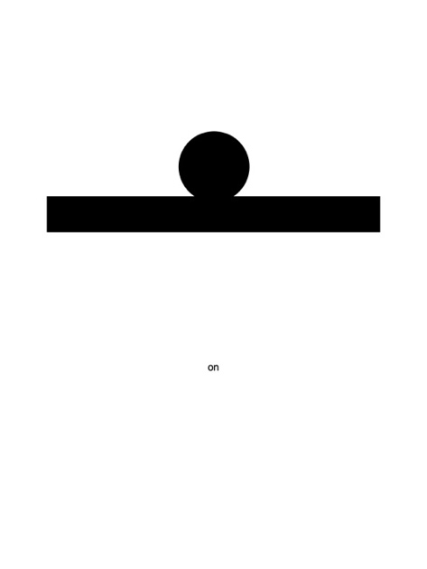 | Off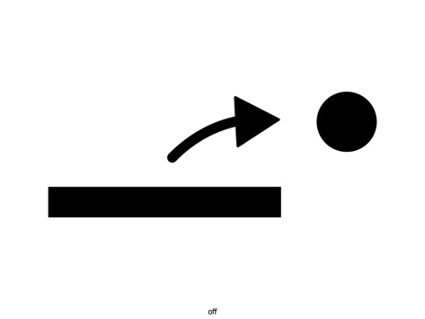 | Calm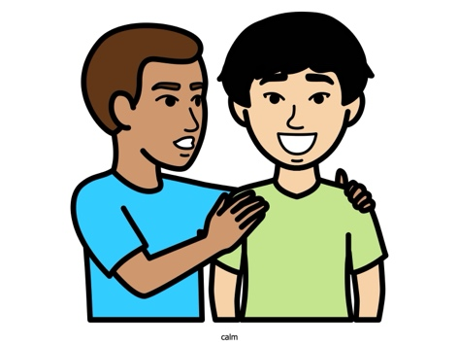
Anxious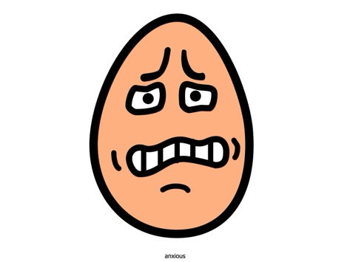 | Heavy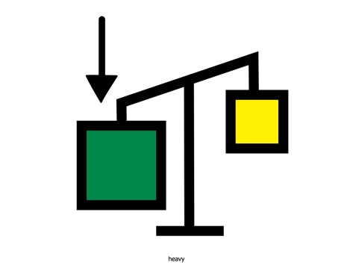 | Light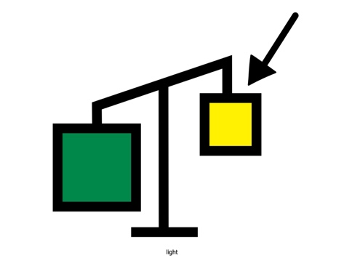
Lap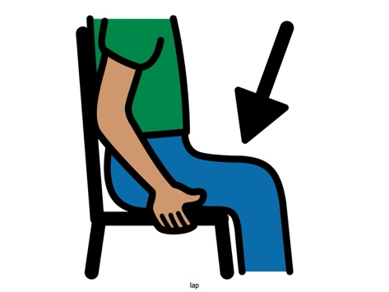 | Help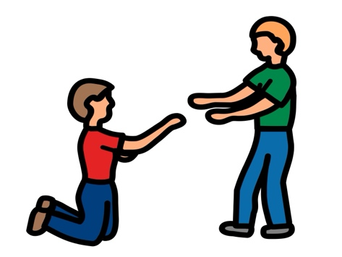 | Arms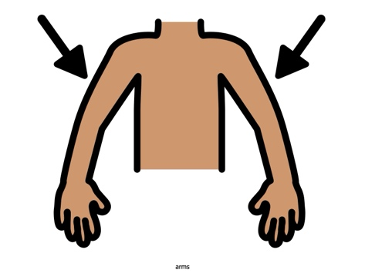
*”Adaptations” adapted from: Haugen’s Modes for Adapting Toys based on materials from the "Let's Play" Project at the University of Buffalo
PCS is a trademark of Tobii Dynavox, LLC. All rights reserved. Used with permission.

